NEPAL COLLEGE OF INFORMATION TECHNOLOGY
Model Set: I

Program : BE SE Time : 3 hrs
Semester : I FM: 100
Subject : DS PM: 45

- Candidates are requested to give their answer as far as practicable in their own words.
- Attempt all questions
- Figure on the margin indicates full marks

- (a) In a renowned software development company of 240 computer programmers 102 employees are proficient in Java, 86 in C#, 126 in Python, 41 in C# and Java, 37 in Java and Python, 23 in C# and Python, and just 10 programmers are proficient in all three languages. [5]
i) How many computer programmers are there those are not proficient in any of these three languages?
ii) How many are proficient in Java only.
(b) Express the GCD of 56 and 15as linear combination of 56 and 15. [5]
(c) A coin is flipped 10 times where each flip comes up either heads or tails. How many possible outcomes: [5]
i) Contain at most three tails? (ii) Contain the same number of heads and tails?

- (a) Define closure of a relation. Let A= {1, 2, 3, 4} and let R = {(1, 2), (2, 3), (3, 4), (2, 1)}. Find the transitive closure of R using warshall’s algorithm. [7]
(b) Solve the recurrence relation: a_{n} - 6a_{n-1} + 8a_{n-2} = 3; a₀ = 10, a₁ = 25. [8]

- (a)What is Logical Equivalence? Find converse, contrapositive, and inverse of: “If it snows tonight, then I will stay at home.” [7]
(b) Show that the premises “There is someone in this class who has been to Pokhara.” “Everyone who goes to Pokhara visit Sarankot.” imply the conclusion “Someone in this class has visited Sarankot.” [8]

- (a) Use Mathematical induction to show that: 8^{n} – 3^{n} is divisible by 5. [7]
(b) Differentiate between universally quantified and existentially quantified statement. What is the truth value of the statement, for every real number x, x²-1>0. [8]

- (a) Prove that a graph has Euler trial but not Eulerian circuit if and only if it has exactly two vertices of odd degree and rest vertices of even degree. [7]
OR
When is K_{m, n} graph Hamiltonian where ‘m’ and ‘n’ are positive integers?

(b) Find the maximum flow in the given network: [8]
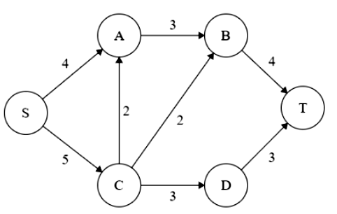

- (a) Design a finite state automata that accepts only those strings over {0, 1} that ends with 11 and contains even number of 1’s and other strings over {0, 1} should be rejected. Your design should include the proper definition of the finite-sate automation, transition table and the transition diagram. [7]

(b) Let G= {N, T, S, P}, where N= {A, B, C}, T = {a, b, c}, S=A and P= production rule given by: A → aaA, A → bB, B →cCb, B → cb, C → bbC, C → bb. State which of the following are in L (G)? [8]
i) aabcb ii) abbcb iii) aaaabcbb iv) aaaabcbbb v) abcbbbbb
OR
Explain Chomsky Hierarchy of grammar in detail.

- Write short notes on (any two): [2*5]
(a) Bijective Function
(b) Regular Expressions
(c) POSET

